ST BRIGID’S SCHOOL

Stationery List for 2024
Dear Parent/Caregiver

Your son/daughter will be in Room 2 and below is a list of stationery required.

Stationery - New Entrant |  | Quantity
Warwick 1A5 unruled exercise book |  | 1
40 pocket display book |  | 1
Clever Kiwi activity book | 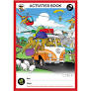 | 3
HB pencil (Staedtler brand) - unnamed (to be used as part of a class set) |  | 2
Small coloured chalk - 12 pack (eg crayola or kookie brand) |  | 1
Amos glue stick (35gm) - this specific brand please |  | 3
Muesli bar for emergency supply (in a named bag) |  | 2
Box of tissues (to be left in the classroom) |  | 1

Items to be purchased from Warehouse Stationery
WS Junior Math 1 Tahi Red | 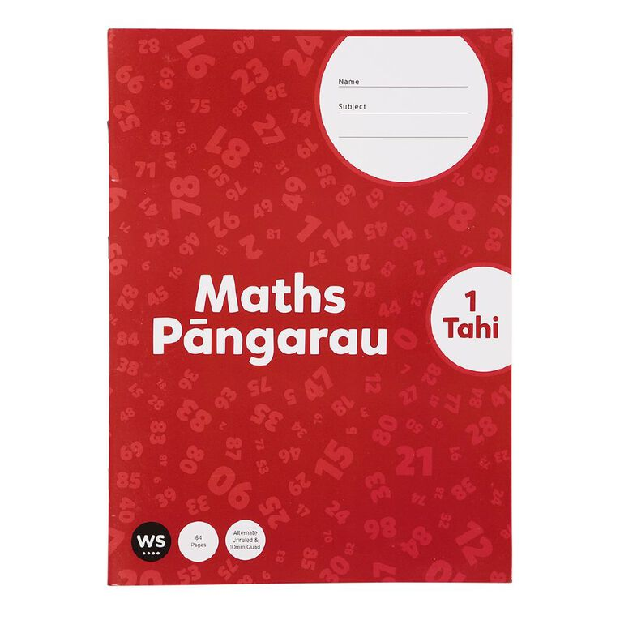 | 1
WS Junior Literacy 1 Tahi Yellow | 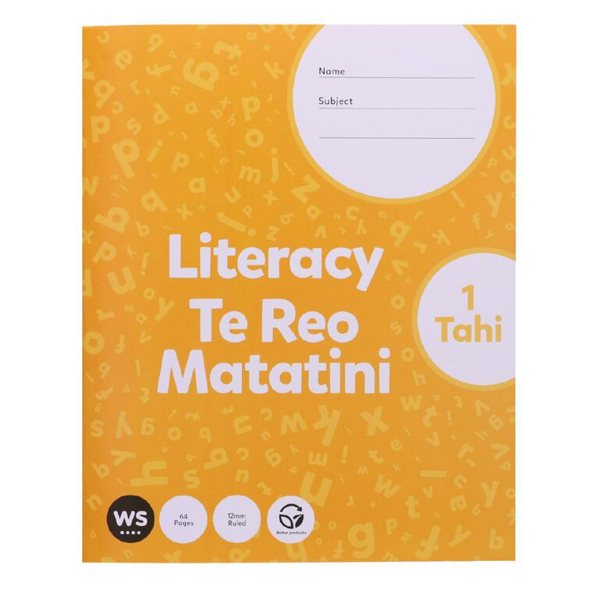 | 2

Items to be purchased from school office |  | Cost
Specific whiteboard pen – unnamed, for your child to use as part of a class set | 2 | $1.60 each
OfficeMax black mini magnetic whiteboard marker with eraser | 2 | $1.20 each
Eraser - unnamed, for your child to use as part of a class set | 1 | 70 cents
Book pouch | 1 | $4.00

