ST BRIGID’S SCHOOL

Stationery List for 2024

Dear Parent/Caregiver

Your son/daughter will be in Room 8 and below is a list of stationery required.

Stationery - Year 3 | Quantity
Warwick 1I8 exercise book – 9mm ruled | 4
Warwick My Everyday Book 1 Unruled 64 Pages | 1
Clever Kiwi Activity Book | 1
40 pocket display book (clearfile) | 1
30cm ruler | 1
Amos Glue stick (35gm) – this specific brand please – please name each stick | 3
HB pencil (Staedtler brand) – please name each pencil | 10
Pencil sharpener | 1
Ballpoint pen - black | 1
Pencil case (needs to fit into tote tray) | 1
Coloured pencils – pack 12 | 1
Felt pens - pack | 1
Box of tissues (to be left in the classroom) | 2
Muesli bar for emergency supply (in a re-sealable named bag) | 2

Items to be purchased from Warehouse Stationery
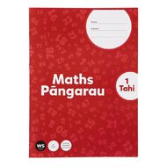  Impact Maths (Pangarau) Book One |  | ¹
Faber-Castell Eraser PVC Free (Small) this specific brand please | 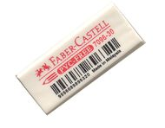 | 1

Items to be purchased from the school office |  | ^{Cost}
Specific Whiteboard pen – unnamed, for your child to use as part of class set | 4 | $1.60 each
Switch on to Spelling | 1 | $5.00

